Exno: 7

Date:

**SUB QUERY**

**AIM:**

To create a table employee and select employee’s name who is amanger and working in Chennai.

1. To create a table employee:

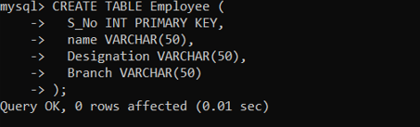

1. Insert values into the table:

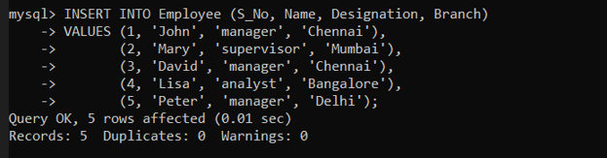

1. Select employee’s name whose designation is manager and working in Chennai:

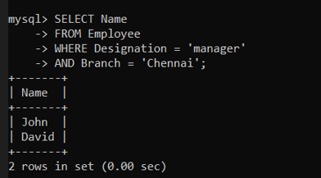

Result:

The table is created, five values have been inserted and selected the employee’s whose designation is manager and working in Chennai.